Uniting Hearts and Hopes
Every act of kindness begins with care.
At RKM Foundation, we carry that care forward—bridging your generosity to the lives of those who need it most.

Our Seven Pillars of Hope (Scroller – 7 Boxes)
Life’s challenges are never one-dimensional—and neither is compassion. That’s why our work is guided by seven pillars of hope:
My Self | My People | My Animals | My Environment | My Religion (Humanity) | My Country | My World
Together, these pillars allow us to respond to diverse needs over time—without limiting compassion to a single cause.
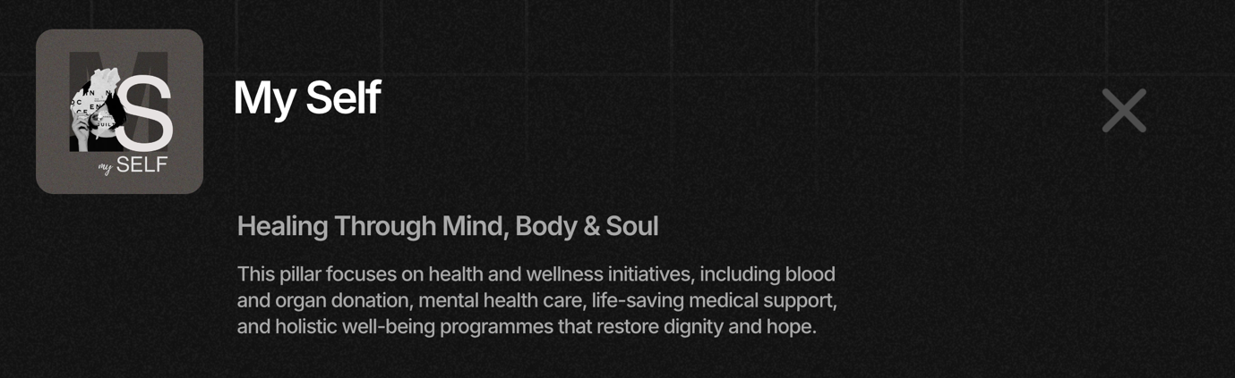
BELOW MYSELF THE TAG LINE SHOULD COME AND IF PEOPLE WANT TO READ MORE THE PLUS TO BE CLICKED AND THE ENTIRE PARA TO BE SHOWCASED – THE IMAGE THEN NEEDS TO CHANGE SIZE
ONE CLICK ONLY – THE PARA BELOW TO SHOW CASE
ALWAYS DISPLAYED / ON SCROLL – IMAGE WITH TAG LINE
WRITE UP NEEDS TO BE UPDATED AS BELOW

MY SELF
Healing Through Mind, Body & Soul
Supports health and well-being through organ and blood donation, mental health care, life-saving medical support, and initiatives that restore dignity and hope.

MY PEOPLE
Fulfilling Dreams
Uplifts children, families, and communities through education, nutrition, access to essentials, and support across all stages of life.

MY ANIMALS
A Voice for the Voiceless
Protects animals through rescue, medical care, vaccination drives, shelter support, and long-term welfare efforts.

MY ENVIRONMENT
Saving Tomorrow
Cares for the planet through tree plantation, cleanliness drives, conservation, sustainability initiatives, and climate-positive action.

MY RELIGION (Humanity)
Serving in Times of Need
Responds to emergencies with food, medical aid, disaster relief, and compassionate humanitarian support.

MY COUNTRY
Fueling Dreams, Building India
Strengthens India through rural development, skill-building, safety initiatives, digital empowerment, and inclusive nation-building efforts.

MY WORLD
Helping Hands, Globally
Extends support to Indians beyond borders through international relief, legal aid, emergency assistance, and cross-border humanitarian action.

Our Way of Creating 360° Holistic Impact
Instead of spreading efforts thin, every month we focus on one pillar and one cause at a time, working closely with trusted grassroots partners.
(THE ABOVE SHOULD BE ALWAYS DISPLAYED) – BELOW SHOULD HAVE THIS EFFECT) – ALIGNEMENT – JUSTIFY ETC.
This ensures every contribution is used with care, clarity, and purpose.
Over time, this creates true 360° holistic impact, because hope isn’t confined to a single problem.

How the Cycle Works (Illustrative)
Our work follows a simple monthly rhythm shaped by real needs on the ground:
- This Month: My Self — Organ donation awareness
- Next Month: My People — Nutrition support for children in need
- Following Month: My Animals — Vaccination drives for street dogs
As needs change, the cycle adapts—ensuring relevance, continuity, and lasting outcomes.
IMAGE NEEDS TO CHANGE

Ways You Can Be Part of the Mission (Scroller)
- Give Time – Volunteer with us
- Give Financial Support – One-time or monthly giving
- Give Skills – Share your expertise
- Give Resources – Donate essentials
- Spread the Word – Be a voice for the cause
IMAGES, WRITE UP & LINK PAGE NEEDS TO CHANGE

Our People
RKM Foundation is guided by committed individuals who bring experience, integrity, and heart to the work.
Board of Trustees
Mr. Ramesh Mundhra I Mrs. Kusum Mundhra I Mr. Karan Mundhra = PLUS SYMBOLS = BOXES SHOULD BE THE SAME SIZE – IMAGES ?
Core Management Team
Mr. Arvind Sarda I Mrs. Rashmi Sarda I Mrs. Natassha Shah I Mr. Ankit Pallan I Mrs. Vyoma Vora I Mrs. Brinda Palan
Lead Coordinators
Mr. Aryan Sarda I Ms. Ahanaa Sarda
Images + Write up to be included

Join A Community That Cares
Your generosity is more than a donation—it’s a promise that no one is forgotten.
Through our 360° holistic approach, your care helps spark hope and transform lives.
Donate Now Button

SEO (Invisible to Users)
SEO Page Title
About RKM Foundation | Uniting Hearts and Hopes Across India
Meta Description
RKM Foundation is a registered charitable trust in India, connecting generosity to real needs across health, communities, the environment, and humanitarian causes. Donations are eligible for CSR and 80G tax benefits.

